Performance Testing
Step 1: Testing Overview
Field | Details
Testing Tool Used | Thunder Client
Type of Testing | API Response / Functional Performance Check
Target Module / API | AI Blog Generation API – POST /api/ai/generate-blog
Test Environment | Local – http://127.0.0.1:5000
Test Date | 25 September 2026

Step 2: Test Scenarios
S.No | Test Scenario / Description | No. of Virtual Users | Duration (sec) | Expected Outcome
1 | AI blog generation API request using topic and category | 1 | Single request | API returns generated blog content successfull
2 | API response verification | 1 | Single request | HTTP 201 Created response is received
3 | Response time observation | 1 | Single request | Response completes and time is recorded
4 | API/server connectivity check | 1 | Single request | Local API responds without connection failure

Step 3: Performance Test Results
S.No | Metric | Target Value | Actual Value | Status (Pass / Fail)
1 | Response Time (Avg) | < 2 seconds | 10.72 seconds* | Not applicable to load test
2 | Response Time (Max) | < 5 seconds | 10.72 seconds* | Not applicable to load test
3 | Throughput (Req/sec) | — | Not measured | Pending
4 | Error Rate | < 1% | 0% for shown request* | Not applicable to load test
5 | CPU Utilization | < 80% | Not measured | Pending
6 | Memory Utilization | < 80% | Not measured | Pending

*The 10.72-second value is the single API request time visible in the supplied screenshot; it is not an average/max from a multi-user load test.
Step 4: Observations & Analysis
The AI blog generation endpoint was tested locally through Thunder Client. The supplied output shows a successful HTTP 201 Created response and generated blog content. The displayed response time is 10.72 seconds for the shown request. A complete load/performance test with multiple virtual users is required to calculate reliable average response time, throughput, error rate, CPU utilization and memory utilization.
Step 5: Screenshots / Evidence
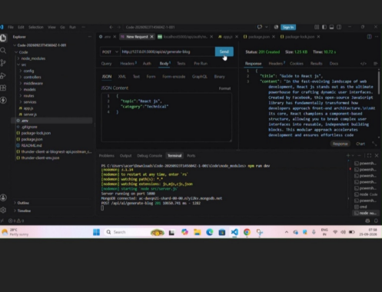Figure 1: AI Blog Generation API – successful 201 Created response with 10.72-second response time.

